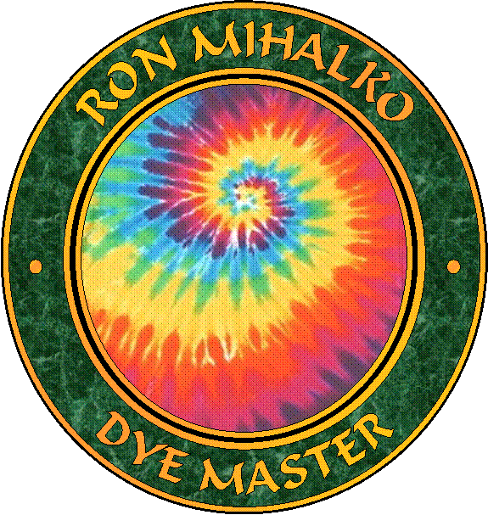
Ron’s Tie-Dye Instructions

MX dyes (fiber reactive dye – dichlorotriazine) recommend Procion®
can dye cotton, rayon, hemp, and silk

5 Basic colors that almost all other colors can be made:

Lemon Yellow: MX-8G or PR1
Fuschia Red: MX-8B or PR13
Turquoise: MX-G or PR25
Cobalt Blue: MX-2G or PR22

Black: MX-CWNA or PR250

recommend using within 3 hours of mixing

Other ingredients needed:

Bottled water or water softener for hard water (Sodium Hexametaphosphate) Calgon

Urea (Organic Nitrogen) 1-5 lbs.

Soda Ash (Sodium Carbonate) 1-5 lbs.
Fixer

Kelp (Sodium Alginate) 8 oz.-1 lb.
Dye Thickener

Synthrapol (prewash/afterwash) 1 qt.
Ph neutral detergent

Non-iodized salt - for black dye mix

Vinegar

Supplies needed:
2- 1 gallon jugs
1- 2 gallon bucket
5- wide mouth plastic bottles
5- plastic squeeze bottles
4- 1 cup plastic cups/bowls
Funnel, whisk, measuring cup, measuring spoons (tsp/ tbsp), scissors, gloves
Plastic box with a grate and lid
Permanent marker

Optional:
Cooler/ refrigerator
Microwave oven

Solutions: Mark containers with titles

Softened Water: 1 gallon jug
½ gallon of lukewarm water
2 tsp. of water softener

Dye Pre-Mix: 1 gallon jug
½ gallon hot water, 1 tsp. Kelp
2 tsp. water softener, 2 cups Urea
(cool to room temperature before mixing with dyes)

Soda Ash: 2 gallon bucket
1 gallon of lukewarm water
1 cup of soda ash
4 tsp. water softener

Dye mixing: wide mouth plastic bottle
Concentrates (used for mixing and/or dying)
1 cup of Dye Pre-Mix solution
*2 tbsp. of dye (Yellow and Red) or 3 tbsp. (Cobalt) or 3 ½ tbsp. (Turquoise) or 4 ½ tbsp. of dye (Black) + 2 tbsp. salt

When other color dyes have been purchased:
2 tbsp. of dye (purples/oranges/earth tones)
3 tbsp. of dye (blues/greens)

To make standard colors:
Red- 2/3 Fuschia, 1/3 Yellow
Orange- 90% Yellow, 10% Fuschia
Purples- Fuschia/Turquoise or
Fuschia/Cobalt
Greens- Yellow/Turquoise or Yellow/Cobalt

To make different shades:
Dilute only with softened water. Remember, dye in bottle is darker than it will be when dried.
Tie-Dying Process:

1. Wash in cold water with water softener. (1/2 cup for small load, ¾ cup for medium load, 1 cup for large load)

2. Scour, if needed. (Some garments are pretreated, flame retardants or wrinkle-free solutions) Wash in hot water with water softener, 1 tsp. Synthrapol and 1 tsp. Soda Ash for every 2 shirts.

3. Fold shirt in desired pattern, tie off and soak with soda ash for at least 15 mins. (Folding instructions for the most common designs are below).

4. Dye shirt on grate over plastic box with squeeze bottles.

5. Let dye react or dry, then cut off ties. (At 70° F it takes about 12 hrs, at 60° F it takes about 18 hrs.) Another option is to microwave in a sealed plastic bag for 3-5 minutes on high. (This is the best way for silk garments.)

6. Fill wash machine with hot water, so that steam rises, once its starts agitating, place shirts in washer and let agitate for 30 seconds. Drain and spin. Refill wash machine with hot water and add Synthrapol (2 tsp small load, 4 tsp for medium load, and 6 tsp. for large load). Go through entire hot/cold wash cycle.

7. Hang to dry.

8. Wash with warm water and vinegar (1 cup for small load, 1 ½ cups for medium load, 2 cups for large load).

Wear your art!

Soda Ash solution may be stored indefinitely.

Mixed dyes should be refrigerated or placed in a cooler after 3 hours. I recommend mixing new dyes instead of reusing if dying another day.

Suppliers:
Dharma Trading Company
P.O. Box 150916
San Rafael, CA 94915
(415) 456-7657
800 542-5227
http://www.dharmatrading.com

Fabrics To Dye For
1 Charlestown Beach Road
Charlestown, RI 02813
(401) 364-3229
888 322-1319
http://www.fabricstodyefor.com

Grateful Dyes, Inc.
Colorado Wholesale Dye Corp.
5325 S. Broadway
Littleton, CO 80121
(303) 763-8774
800 697-1566
http://www.bestdye.com

Standard Dyes, Inc.
P.O. Box 2808
High Point, NC 27261-2808
(336) 841-5468
800 859-1240
http://www.standarddyes.com

Consolidated Plastics, Inc.
8181 Darrow Rd.
Twinsburg, OH 44087
800 362-1000
http://www.consolidatedplastics.com

Pattern Folding Instructions

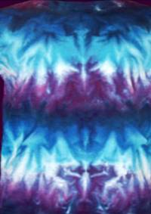
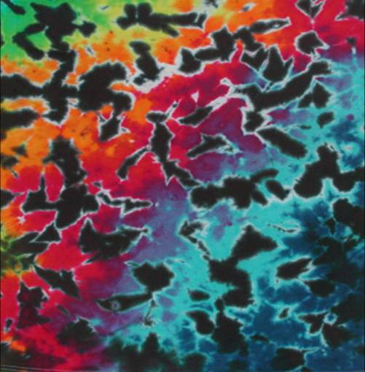

Gradations and Crinkles:

1. Turn shirt inside out.
2. Fold in half, with the front side of the shirt inside.
3. Straighten out any creases or wrinkles, especially along the crease.
4. Scrunch fabric to form a series of ripples while keeping layers of shirt from separating. Try to get them 1 ½” – 2” tall.
5. Pour Soda Ash solution over shirt, ensuring total saturation, and tighten ripples. Let stand for a minimum of 15 minutes.
6. Dye shirt. Flip and dye with same corresponding positions.
For Crinkle patterns, dye one side black, the other side with the other colors.

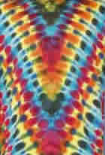
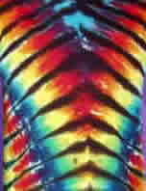

V Tiger V Dragon Completed Fold

V Stripes:

For V Tiger patterns:
1. Turn shirt inside out.
2. Fold in half, with the front side of the shirt inside.
3. Straighten out any creases or wrinkles, especially along the crease.
4. Determine the angle of your “V”, draw a line (fold line) perpendicular to the “V” line.
5. Scrunch a fold (1 ½” – 2” tall) along fold line, then scrunch a series of folds and pack together.
6. Pour Soda Ash solution over shirt, ensuring total saturation, and tighten foldss. Let stand for a minimum of 15 minutes.
7. Dye shirt. One side all black, flip and dye other side with other colors.

For V Dragon patterns:
Steps 1 through 4 are the same. In step 5, tie off shirt every 2-3 inches, tight enough to cause shirt to compress.
6. Soak in Soda Ash solution (minimum of 15 mins.). Squeeze out and let dry (may take up to 3 days).
7. Dye shirt with various colors on one side, dye other side with different colors and in a different order.

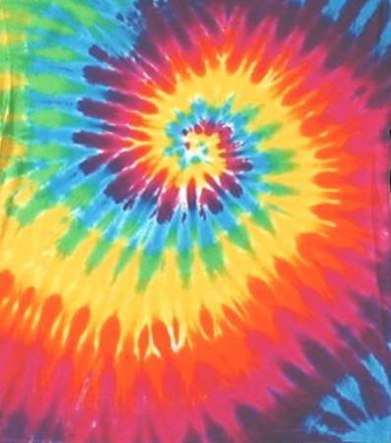
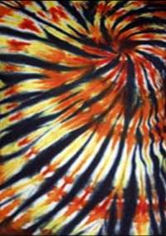

Stained Glass Rainbow

Spirals:

For Stained Glass patterns:
1. Mark center of spiral.
2. Turn shirt inside out.
3. Use a fork or fingers to start spiral.
4. Twist in a clockwise direction at spiral center.
5. As spiral pattern forms, arrange folds so they are an even height (1 ½” - 2” tall) and pack tightly.
6. Continue to form pattern by moving shirt counter-clockwise around center.
7. When spiral center is several inches across, remove fork and use the palm of your hand to hold center stationary.
8. Continue to arrange even height folds and pack together.
9. When pattern reaches the edges of the shirt, rotate center clockwise, use torque to tighten spiral as much as possible.
10. Tie off across the diameter, tie another perpendicular to the first while keeping the spiral flat as it compresses.
11. Continue to tie across diameter until there are no more loose edges.
12. Soak in Soda Ash solution for a minimum of 15 minutes.
13. Dye shirt. One side all black, flip and dye other side all yellow, then add the other colors.

For Rainbow patterns:
Steps 1 through 12 are the same.
13. Let dry completely (may take up to 3 days).
14. Dye shirt. Flip and dye with same colors and corresponding positions.


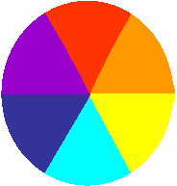

Stained Glass Rainbow

